**What is Power BI?**

**Power BI** is a collection of software services, apps, and connectors that work together to turn your unrelated sources of data into coherent, visually immersive, and interactive insights. Your data may be an Excel spreadsheet, or a collection of cloud-based and on-premises hybrid data warehouses. Power BI lets you easily connect to your data sources, visualize and discover what's important, and share that with anyone or everyone you want.

## The parts of Power BI

Power BI consists of several elements that all work together, starting with these three basics:

* A Windows desktop application called **Power BI Desktop**.
* An online SaaS (Software as a Service) service called the **Power BI service**.
* Power BI **mobile apps** for Windows, iOS, and Android devices.

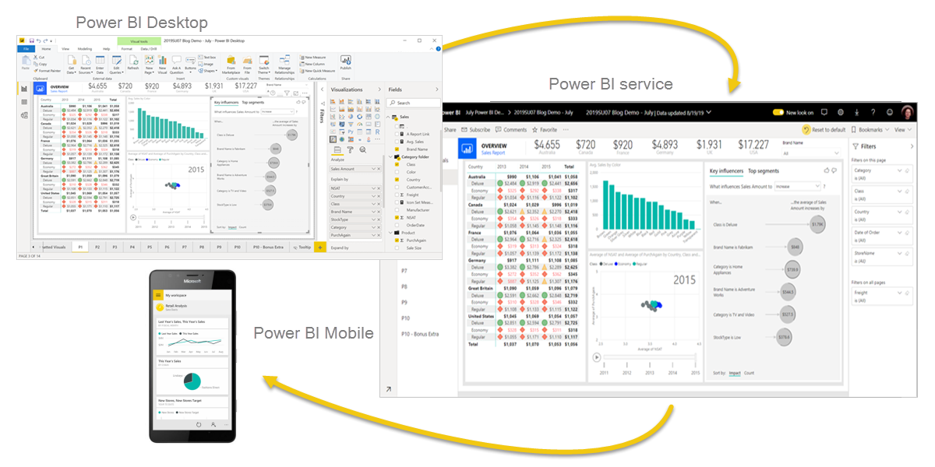

These three elements—Power BI Desktop, the service, and the mobile apps—are designed to let you create, share, and consume business insights in the way that serves you and your role most effectively.

Beyond those three, Power BI also features two other elements:

* **Power BI Report Builder**, for creating paginated reports to share in the Power BI service.
* **Power BI Report Server**, an on-premises report server where you can publish your Power BI reports, after creating them in Power BI Desktop.

# Comparing Power BI Desktop and the Power BI service

**Power BI Desktop** is an application that you download and install for free on your local computer. Desktop is a complete data analysis and report creation tool that is used to connect to, transform, visualize, and analyze your data. It includes the Query Editor, in which you can connect to many different sources of data, and combine them (often called modeling) into a data model. Then you design a report based on that data model.

The **Power BI service** is a cloud-based service, or software as a service (SaaS). It supports report editing and collaboration for teams and organizations. You can connect to data sources in the Power BI service, too, but modeling is limited. The Power BI service is used to do things such as creating dashboards, creating and sharing apps, analyzing and exploring your data to uncover business insights, and much more.

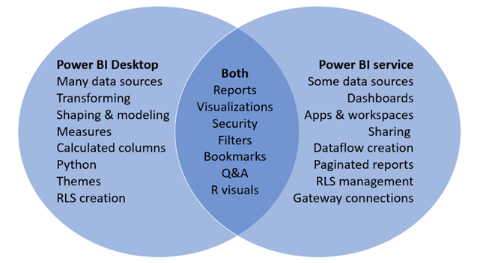

# What is Power BI Desktop?

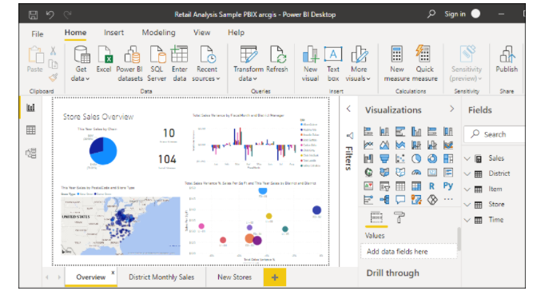

**The most common uses for Power BI Desktop are as follows:**

* Connect to data
* Transform and clean that data, to create a data model
* Create visuals, such as charts or graphs, that provide visual representations of the data
* Create reports that are collections of visuals, on one or more report pages
* Share reports with others by using the Power BI service

**For a Power BI business user, the five building blocks**

are: **visualizations**, **dashboards**, **reports**, **apps**, and **datasets**. These are sometimes referred to as Power BI **content**. Content exists in **workspaces**. A typical workflow involves all of the building blocks: A Power BI designer (yellow in diagram below) collects data from datasets, brings it into Power BI for analysis, creates reports full of visualizations that highlight interesting facts and insights, pins visualizations from reports to dashboards, and shares the reports and dashboards with business users like you (black in diagram below). The designer shares them in the form of dashboards, reports, or apps.

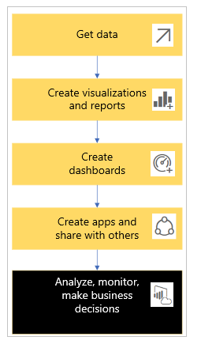

At its most basic:

* A screenshot of the visualization icon. a **visualization** (or visual), is a type of chart built by Power BI designers. The visuals display the data from reports and datasets. Typically, designers build the visuals in Power BI Desktop.
* A screenshot of the database icon. A dataset is a container of data. For example, it might be an Excel file from the World Health Organization. It could also be a company-owned database of customers or it might be a Salesforce file. Datasets are managed by designers.
* A screenshot of the dashboard icon. A dashboard is a single screen with interactive visuals, text, and graphics. A dashboard collects your most important metrics, on one screen, to tell a story or answer a question. The dashboard content comes from one or more reports and one or more datasets.
* A screenshot of the report icon. A report is one or more pages of interactive visuals, text, and graphics that together make up a single report. Power BI bases a report on a single dataset. Often, the designer organizes report pages to address a central area of interest or answer a single question.
* A screenshot of the app icon. An app is a way for designers to bundle and share related dashboards and reports together. Business users receive some apps automatically but can go search for other apps created by colleagues or by the community. For example, out-of-the-box apps are available for external services you may already use, like Google Analytics and Microsoft Dynamics CRM.

## **Datasets**

A dataset is a collection of data that designers import or connect to and then use to build reports and dashboards. As a business user, you won't interact directly with datasets, but it's still nice to learn how they fit into the bigger picture.

Each dataset represents a single source of data. For example, the source could be an Excel workbook on OneDrive, an on-premises SQL Server Analysis Services tabular dataset, or a Salesforce dataset. Power BI supports many different data sources.

One dataset...

* Can be used over and over by a report designer to create dashboards and reports
* Can be used to create many different reports
* Visuals from that one dataset can appear on many different dashboards

## **Visualizations**

Visualizations (also known as visuals) display insights that Power BI discovers in the data. Visualizations make it easier to interpret the insight, because your brain can comprehend a picture quicker than a spreadsheet of numbers.

## **Reports**

A Power BI report is one or more pages of visualizations, graphics, and text. All of the visualizations in a report come from a single dataset. Designers build reports and share them with others; either individually or as part of an app.

One report...

* Can be associated with multiple dashboards (tiles pinned from that one report can appear on multiple dashboards).
* Can be created using data from only one dataset.
* Can be part of multiple apps.

## **Dashboards**

A dashboard represents a customized graphical view of some subset of the underlying dataset(s). Designers build dashboards and share them with business users; either individually or as part of an app. A dashboard is a single canvas that has tiles, graphics, and text.

**ONE** dashboard...

* can display visualizations from many different datasets
* can display visualizations from many different reports
* can display visualizations pinned from other tools (for example, Excel)

## **Apps**

These collections of dashboards and reports organize related content together into a single package. Power BI designers build them in workspaces and share apps with individuals, groups, entire organizations, or the public. As a business user, you can be confident that you and your colleagues are working with the same information; a single trusted version of the truth.

There are three views available in Power BI Desktop, which you select on the left side of the canvas. The views, shown in the order they appear, are as follows:

* **Report**: In this view, you create reports and visuals, where most of your creation time is spent.
* **Data**: In this view, you see the tables, measures, and other data used in the data model associated with your report, and transform the data for best use in the report's model.
* **Model**: In this view, you see and manage the relationships among tables in your data model.

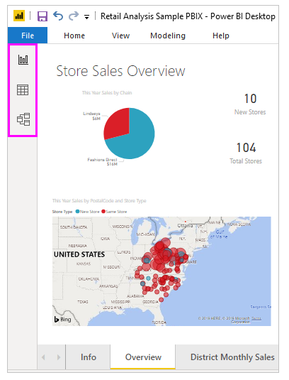

Download power BI from following link.

<https://www.microsoft.com/en-us/download/details.aspx?id=58494>

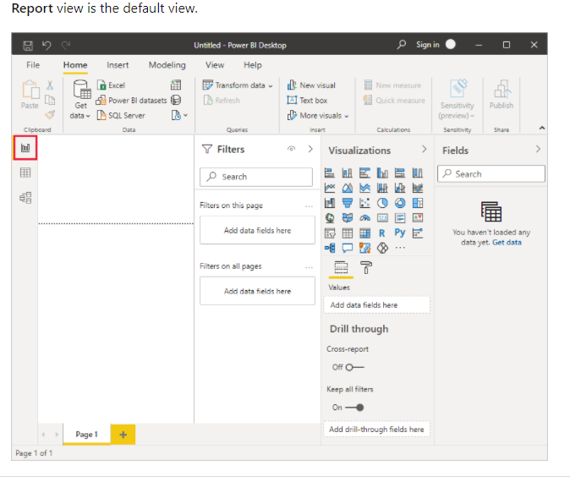

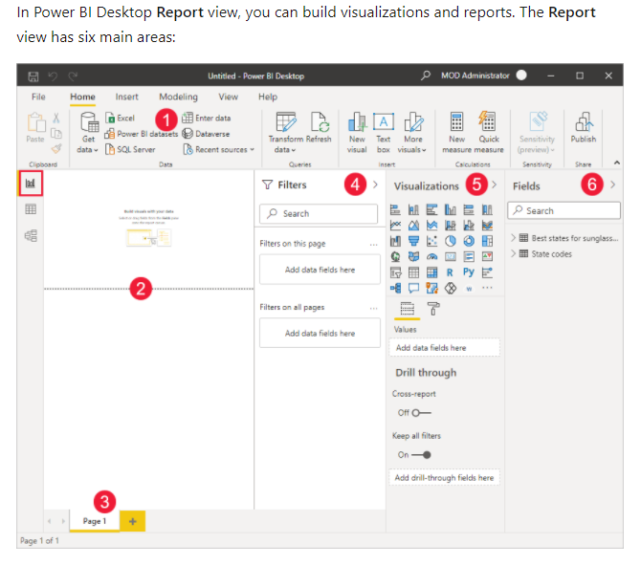

1. The ribbon at the top, which displays common tasks associated with reports and visualizations.
2. The canvas area in the middle, where visualizations are created and arranged.
3. The pages tab area at the bottom, which lets you select or add report pages.
4. The **Filters** pane, where you can filter data visualizations.
5. The **Visualizations** pane, where you can add, change, or customize visualizations, and apply drillthrough.
6. The **Fields** pane, which shows the available fields in your queries. You can drag these fields onto the canvas, the **Filters** pane, or the **Visualizations** pane to create or modify visualizations.